Practical-12
Event Management CRUD with Poster Upload and File Validation
Theory :
- Are add, update, and delete functionalities implemented correctly?
Answer: Yes, users can add, update, and delete event records correctly.
- Is the UI linked with the database correctly?
Answer: Yes, the user interface is connected to the database using PHP and MySQL.
- Are poster uploads validated for type and size?
Answer: Yes, poster uploads are validated to allow supported file types and sizes.
- Are success and failure messages displayed?
Answer: Yes, appropriate success and failure messages are displayed after each operation.

Result:

1)event panel

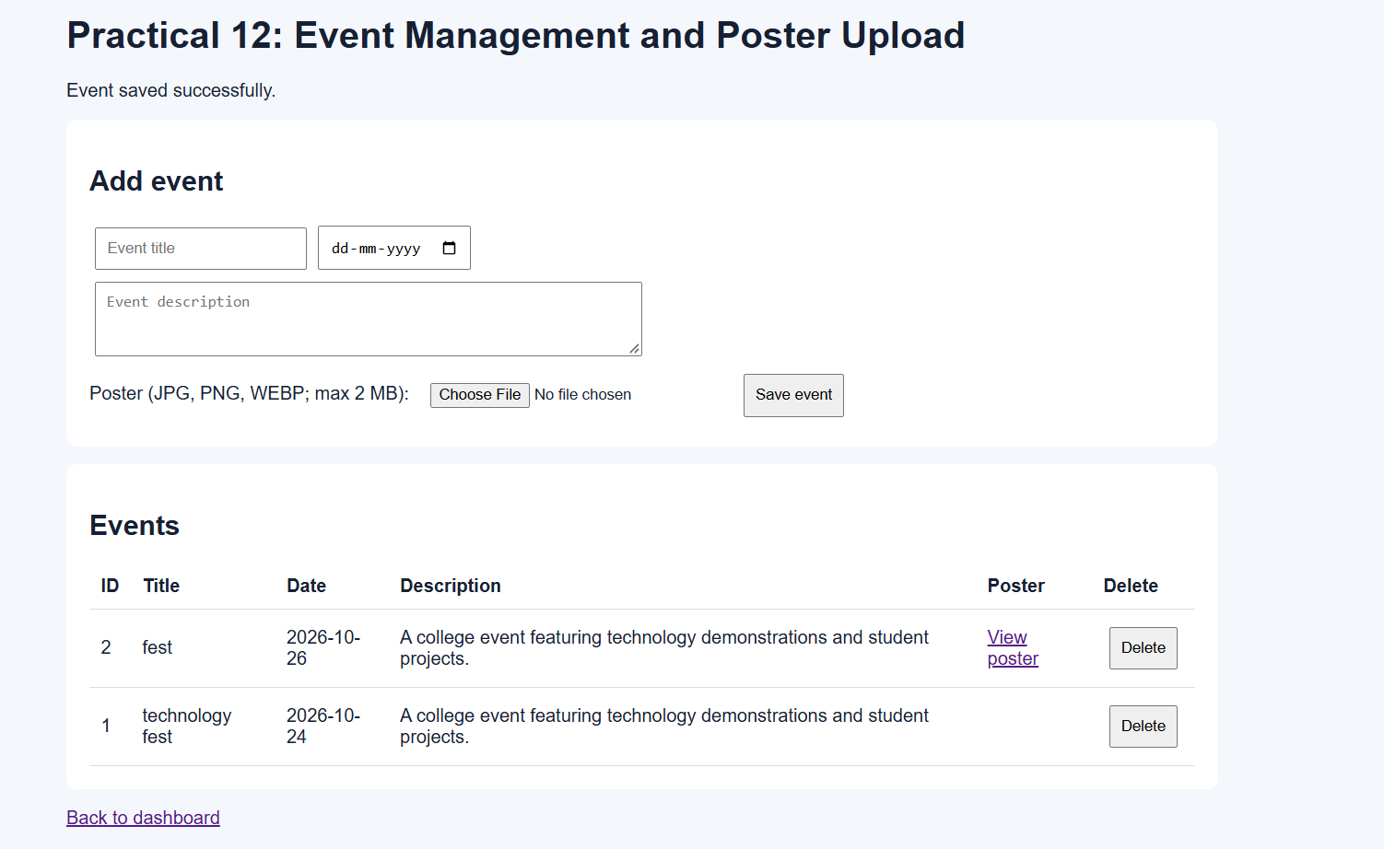
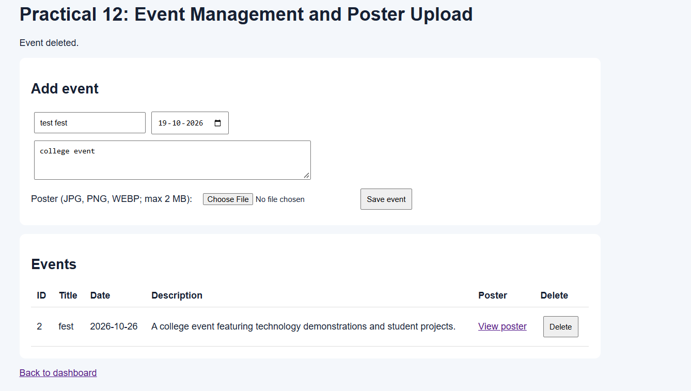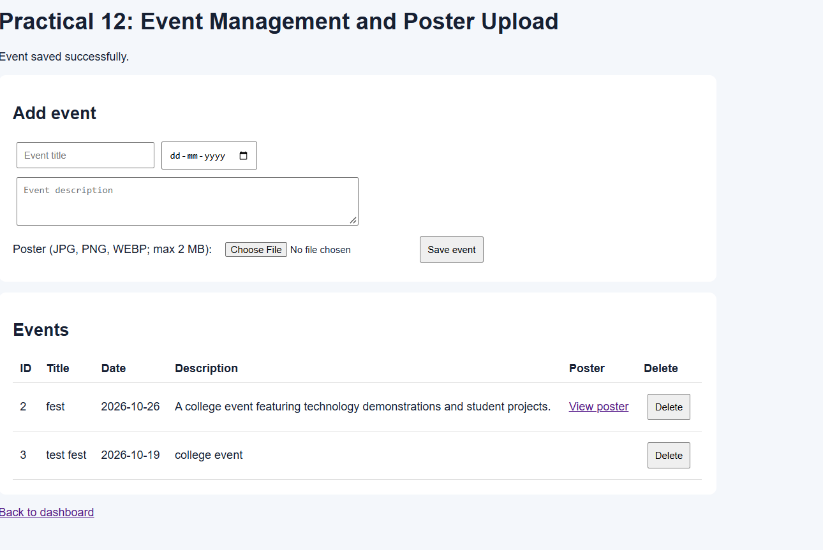
2)event management dashboard
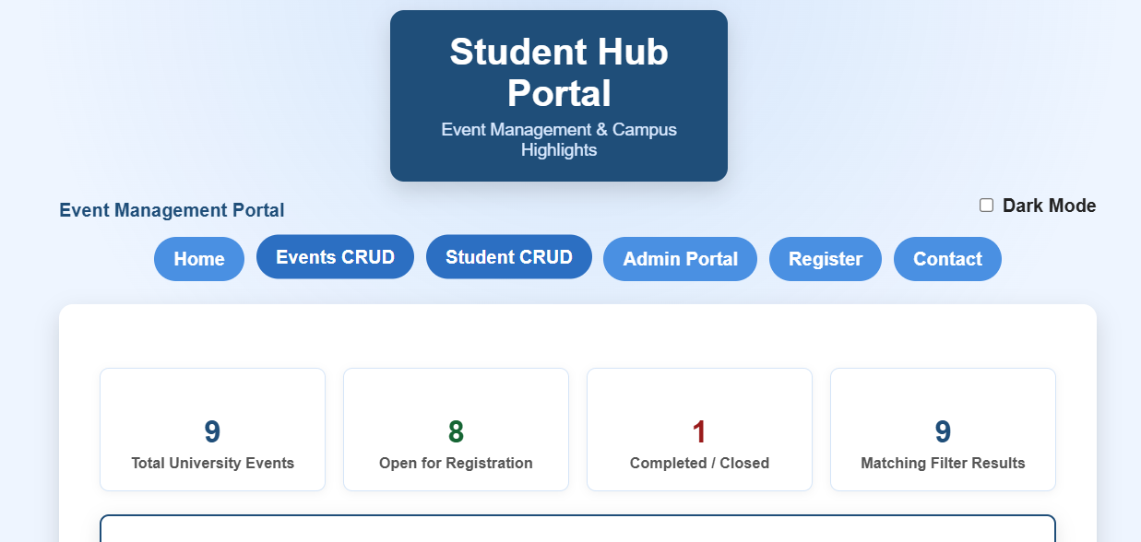

Git Hub Repository Link:
https://github.com/25dce046/STUDENT-HUB-PORTAL
Challenges Faced: I faced difficulties in implementing event CRUD operations using PHP and MySQL. I struggled with uploading event posters and validating their file type and size. I also faced challenges in connecting the UI with the database and displaying appropriate messages.

Learning Outcome:- I learned to add, view, update, and delete event records using PHP and MySQL. I understood how to upload posters with proper file type and size validation. I also learned to connect the UI with the database and display success or failure messages.

